This post will investigate using Principal Components as part of a momentum strategy.

I thought I’d further investigate and translate into code I can explicitly display (as David Varadi doesn’t). Of course, as David Varadi is a quantitative research director with whom I’ve done good work with in the past, I find that trying to investigate his ideas is worth the time spent.

So, here’s the basic idea: in an allegedly balanced universe, containing both aggressive (e.g. equity asset class ETFs) assets and defensive assets (e.g. fixed income asset class ETFs), that principal component analysis, a cornerstone in machine learning, should have some effectiveness at creating an effective portfolio.

I decided to put that idea to the test with the following algorithm:

Using the same assets that David Varadi does, I first use a rolling window (between 6-18 months) to create principal components. Making sure that the SPY half of the loadings is always positive (that is, if the loading for SPY is negative, multiply the first PC by -1, as that’s the PC we use), and then create two portfolios–one that’s comprised of the normalized positive weights of the first PC, and one that’s comprised of the negative half.

Next, every month, I use some momentum lookback period (1, 3, 6, 10, and 12 months), and invest in the portfolio that performed best over that period for the next month, and repeat.

Here’s the source code to do that:

require(PerformanceAnalytics)

require(quantmod)

require(stats)

require(xts)

symbols <- c("SPY", "EFA", "EEM", "DBC", "HYG", "GLD", "IEF", "TLT")

# get free data from yahoo

rets <- list()

getSymbols(symbols, src = 'yahoo', from = '1990-12-31')

for(i in 1:length(symbols)) {

returns <- Return.calculate(Ad(get(symbols[i])))

colnames(returns) <- symbols[i]

rets[[i]] <- returns

}

rets <- na.omit(do.call(cbind, rets2))

# 12 month PC rolling PC window, 3 month momentum window

pcPlusMinus <- function(rets, pcWindow = 12, momWindow = 3) {

ep <- endpoints(rets)

wtsPc1Plus <- NULL

wtsPc1Minus <- NULL

for(i in 1:(length(ep)-pcWindow)) {

# get subset of returns

returnSubset <- rets[(ep[i]+1):(ep[i+pcWindow])]

# perform PCA, get first PC (I.E. pc1)

pcs <- prcomp(returnSubset)

firstPc <- pcs[[2]][,1]

# make sure SPY always has a positive loading

# otherwise, SPY and related assets may have negative loadings sometimes

# positive loadings other times, and creates chaotic return series

if(firstPc['SPY'] < 0) {

firstPc <- firstPc * -1

}

# create vector for negative values of pc1

wtsMinus <- firstPc * -1

wtsMinus[wtsMinus < 0] <- 0

wtsMinus <- wtsMinus/(sum(wtsMinus)+1e-16) # in case zero weights

wtsMinus <- xts(t(wtsMinus), order.by=last(index(returnSubset)))

wtsPc1Minus[[i]] <- wtsMinus

# create weight vector for positive values of pc1

wtsPlus <- firstPc

wtsPlus[wtsPlus < 0] <- 0

wtsPlus <- wtsPlus/(sum(wtsPlus)+1e-16)

wtsPlus <- xts(t(wtsPlus), order.by=last(index(returnSubset)))

wtsPc1Plus[[i]] <- wtsPlus

}

# combine positive and negative PC1 weights

wtsPc1Minus <- do.call(rbind, wtsPc1Minus)

wtsPc1Plus <- do.call(rbind, wtsPc1Plus)

# get return of PC portfolios

pc1MinusRets <- Return.portfolio(R = rets, weights = wtsPc1Minus)

pc1PlusRets <- Return.portfolio(R = rets, weights = wtsPc1Plus)

# combine them

combine <-na.omit(cbind(pc1PlusRets, pc1MinusRets))

colnames(combine) <- c("PCplus", "PCminus")

momEp <- endpoints(combine)

momWts <- NULL

for(i in 1:(length(momEp)-momWindow)){

momSubset <- combine[(momEp[i]+1):(momEp[i+momWindow])]

momentums <- Return.cumulative(momSubset)

momWts[[i]] <- xts(momentums==max(momentums), order.by=last(index(momSubset)))

}

momWts <- do.call(rbind, momWts)

out <- Return.portfolio(R = combine, weights = momWts)

colnames(out) <- paste("PCwin", pcWindow, "MomWin", momWindow, sep="_")

return(list(out, wtsPc1Minus, wtsPc1Plus, combine))

}

pcWindows <- c(6, 9, 12, 15, 18)

momWindows <- c(1, 3, 6, 10, 12)

permutes <- expand.grid(pcWindows, momWindows)

stratStats <- function(rets) {

stats <- rbind(table.AnnualizedReturns(rets), maxDrawdown(rets))

stats[5,] <- stats[1,]/stats[4,]

stats[6,] <- stats[1,]/UlcerIndex(rets)

rownames(stats)[4] <- "Worst Drawdown"

rownames(stats)[5] <- "Calmar Ratio"

rownames(stats)[6] <- "Ulcer Performance Index"

return(stats)

}

results <- NULL

for(i in 1:nrow(permutes)) {

tmp <- pcPlusMinus(rets = rets, pcWindow = permutes$Var1[i], momWindow = permutes$Var2[i])

results[[i]] <- tmp[[1]]

}

results <- do.call(cbind, results)

stats <- stratStats(results)

After a cursory look at the results, it seems the performance is fairly miserable with my implementation, even by the standards of tactical asset allocation models (the good ones have a Calmar and Sharpe Ratio above 1)

Here are histograms of the Calmar and Sharpe ratios.

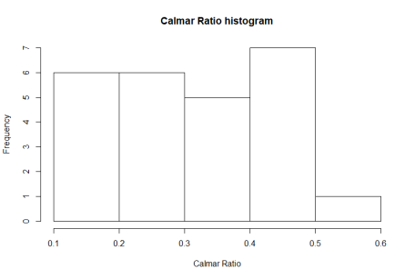  
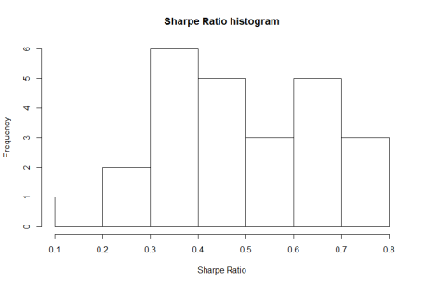

These values are generally too low for my liking. Here’s a screenshot of the table of all 25 results.

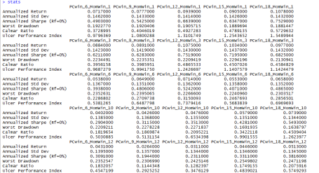

While my strategy of choosing which portfolio to hold is different from David Varadi’s (momentum instead of whether or not the aggressive portfolio is above its 200-day moving average), there are numerous studies that show these two methods are closely related, yet the results feel starkly different (and worse) compared to his site.

I’d certainly be willing to entertain suggestions as to how to improve the process, which will hopefully create some more meaningful results.

Thanks for reading.